**CHAPTER 6**

**EVALUATION DETAILS**

This project is implemented and evaluated using six distinct classification algorithms. They are Random Forest algorithm, Multi-layer perceptron algorithm.

**6.1 Sample Code**

#importing required libraries

import numpy as np

import pandas as pd

import matplotlib.pyplot as plt

%matplotlib inline

import seaborn as sns

from sklearn import metrics

import warnings

warnings.filterwarnings('ignore')

#Loading data into dataframe

data = pd.read_csv("phishing.csv")

data.head()

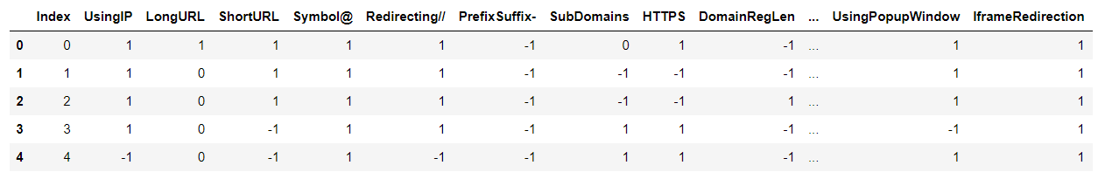

**Fig 6.1 Dataset**

#Shape of dataframe

data.shape

#Listing the features of the dataset

data.columns

#Information about the dataset

data.info()

# nunique value in columns

data.nunique()

#droping index column

data = data.drop(['Index'],axis = 1)

#Correlation heatmap

plt.figure(figsize=(15,15))

sns.heatmap(data.corr(), annot=True)

plt.show()

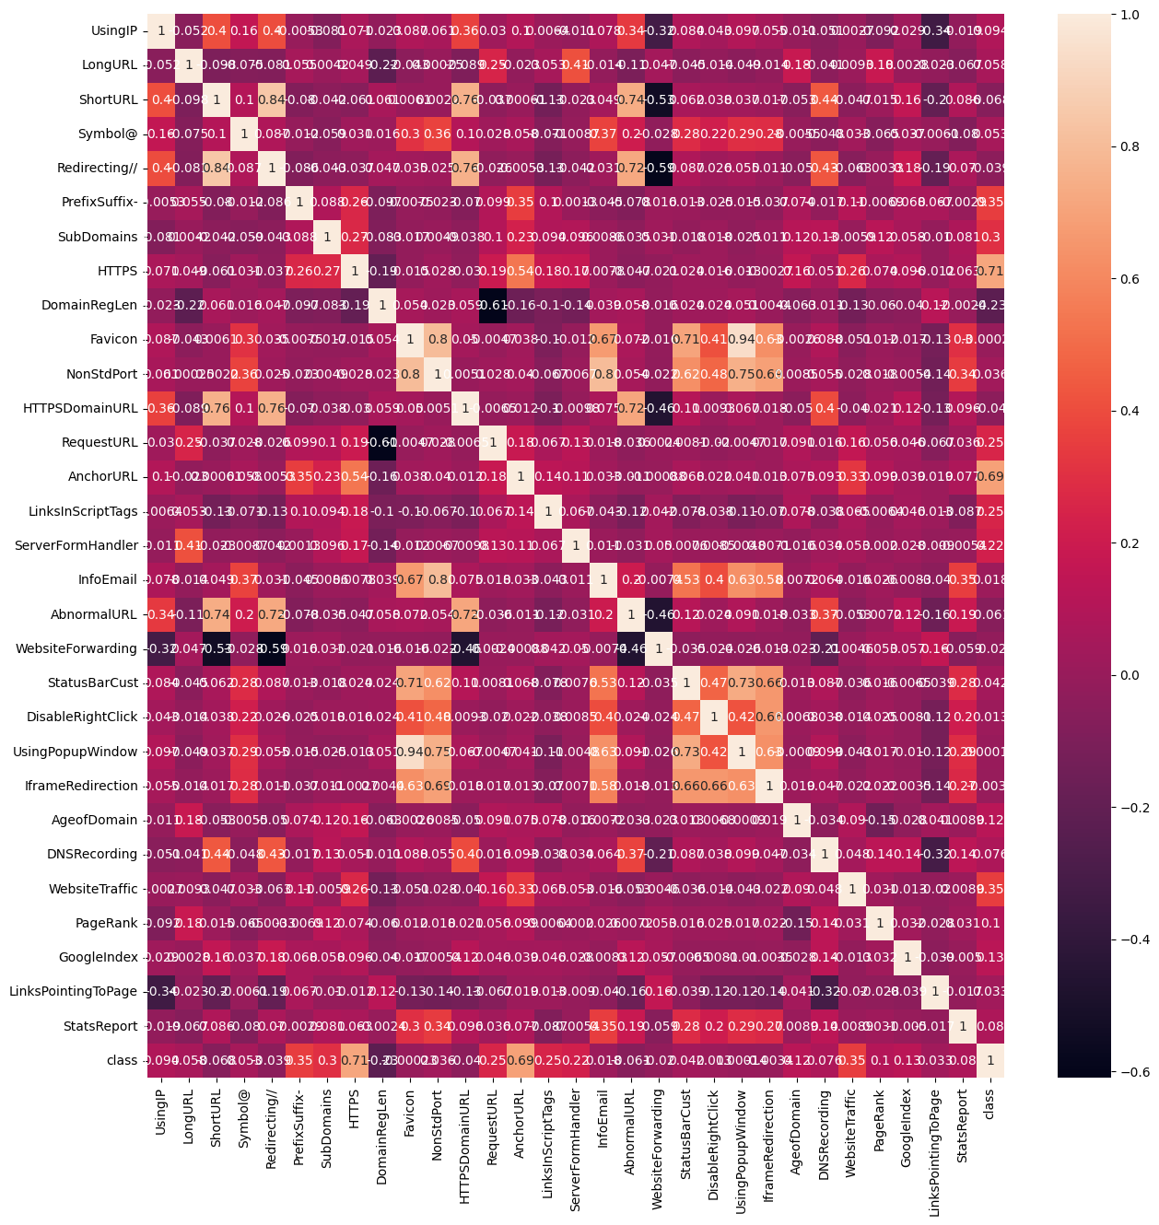

**Fig 6.2 Correlation Heatmap**

# Phishing Count in pie chart

data['class'].value_counts().plot(kind='pie',autopct='%1.2f%%')

plt.title("Phishing Count")

plt.show()

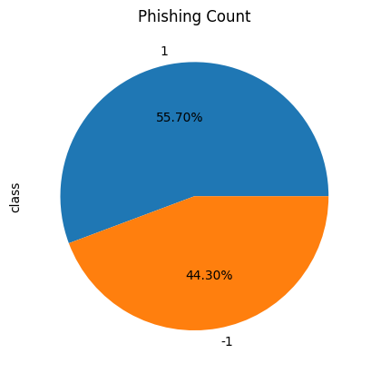

**Fig 6.3 Data Pie Chart**

# Splitting the dataset into dependant and independant fetature

X = data.drop(["class"],axis =1)

y = data["class"]

# Splitting the dataset into train and test sets: 80-20 split

from sklearn.model_selection import train_test_split

X_train, X_test, y_train, y_test = train_test_split(X, y, test_size = 0.2, random_state = 42)

X_train.shape, y_train.shape, X_test.shape, y_test.shape

# Creating holders to store the model performance results

ML_Model = []

accuracy = []

f1_score = []

recall = []

precision = []

#function to call for storing the results

def storeResults(model, a,b,c,d):

ML_Model.append(model)

accuracy.append(round(a, 3))

f1_score.append(round(b, 3))

recall.append(round(c, 3))

precision.append(round(d, 3))

**Random Forest**

# Random Forest Classifier Model

from sklearn.ensemble import RandomForestClassifier

# instantiate the model

forest = RandomForestClassifier(n_estimators=100, random_state=42)

# fit the model

forest.fit(X_train,y_train)

#computing the accuracy, f1_score, Recall, precision of the model performance

acc_train_forest = metrics.accuracy_score(y_train,y_train_forest)

acc_test_forest = metrics.accuracy_score(y_test,y_test_forest)

print("Random Forest : Accuracy on training Data: {:.3f}".format(acc_train_forest))

print("Random Forest : Accuracy on test Data: {:.3f}".format(acc_test_forest))

print()

f1_score_train_forest = metrics.f1_score(y_train,y_train_forest)

f1_score_test_forest = metrics.f1_score(y_test,y_test_forest)

print("Random Forest : f1_score on training Data: {:.3f}".format(f1_score_train_forest))

print("Random Forest : f1_score on test Data: {:.3f}".format(f1_score_test_forest))

print()

recall_score_train_forest = metrics.recall_score(y_train,y_train_forest)

recall_score_test_forest = metrics.recall_score(y_test,y_test_forest)

print("Random Forest : Recall on training Data: {:.3f}".format(recall_score_train_forest))

print("Random Forest : Recall on test Data: {:.3f}".format(recall_score_test_forest))

print()

precision_score_train_forest = metrics.precision_score(y_train,y_train_forest)

precision_score_test_forest = metrics.precision_score(y_test,y_test_forest)

print("Random Forest : precision on training Data: {:.3f}".format(precision_score_train_forest))

print("Random Forest : precision on test Data: {:.3f}".format(precision_score_test_forest))

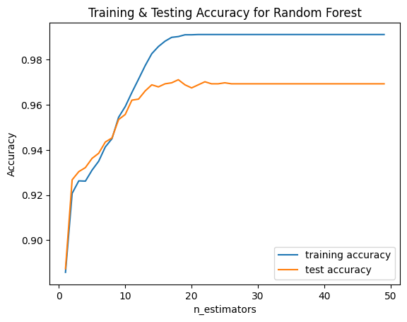

**Fig 6.1: Training & Testing Accuracy for Random Forest**

**LINEAR REGRESSION**

# Linear regression model

from sklearn.linear_model import LogisticRegression

#from sklearn.pipeline import Pipeline

# instantiate the model

log = LogisticRegression()

# fit the model

log.fit(X_train,y_train)

#predicting the target value from the model for the samples

y_train_log = log.predict(X_train)

y_test_log = log.predict(X_test)

#computing the accuracy, f1_score, Recall, precision of the model performance

acc_train_log = metrics.accuracy_score(y_train,y_train_log)

acc_test_log = metrics.accuracy_score(y_test,y_test_log)

print("Logistic Regression : Accuracy on training Data: {:.3f}".format(acc_train_log))

print("Logistic Regression : Accuracy on test Data: {:.3f}".format(acc_test_log))

print()

f1_score_train_log = metrics.f1_score(y_train,y_train_log)

f1_score_test_log = metrics.f1_score(y_test,y_test_log)

print("Logistic Regression : f1_score on training Data: {:.3f}".format(f1_score_train_log))

print("Logistic Regression : f1_score on test Data: {:.3f}".format(f1_score_test_log))

print()

recall_score_train_log = metrics.recall_score(y_train,y_train_log)

recall_score_test_log = metrics.recall_score(y_test,y_test_log)

print("Logistic Regression : Recall on training Data: {:.3f}".format(recall_score_train_log))

print("Logistic Regression : Recall on test Data: {:.3f}".format(recall_score_test_log))

print()

precision_score_train_log = metrics.precision_score(y_train,y_train_log)

precision_score_test_log = metrics.precision_score(y_test,y_test_log)

print("Logistic Regression : precision on training Data: {:.3f}".format(precision_score_train_log))

print("Logistic Regression : precision on test Data: {:.3f}".format(precision_score_test_log))

#computing the classification report of the model

print(metrics.classification_report(y_test, y_test_log))

# Lists to store training and testing accuracy

training_accuracy_logreg = []

test_accuracy_logreg = []

# Try different values of the regularization parameter C

C_values = [0.001, 0.01, 0.1, 1, 10, 100, 1000]

for C in C_values:

# Record training set accuracy

training_accuracy_logreg.append(log.score(X_train, y_train))

# Record generalization accuracy

test_accuracy_logreg.append(log.score(X_test, y_test))

# Plotting the training & testing accuracy for different values of C

plt.plot(C_values, training_accuracy_logreg, label="Training accuracy")

plt.plot(C_values, test_accuracy_logreg, label="Testing accuracy")

plt.xscale('log') # Using a logarithmic scale for better visualization

plt.xlabel("Regularization Parameter (C)")

plt.ylabel("Accuracy")

plt.title("Training & Testing Accuracy for Logistic Regression")

plt.legend()

plt.show()

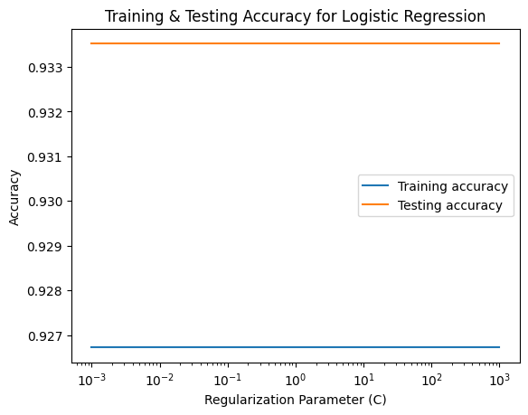

**Fig 6.2: Training & Testing Accuracy for Logistic Regression**

#storing the results. The below mentioned order of parameter passing is important.

storeResults('Logistic Regression',acc_test_log,f1_score_test_log,

recall_score_train_log,precision_score_train_log)

**DECISION TREE CLASSIFIER**

# Decision Tree Classifier model

from sklearn.tree import DecisionTreeClassifier

# instantiate the model

tree = DecisionTreeClassifier(max_depth=30)

# fit the model

tree.fit(X_train, y_train)

#predicting the target value from the model for the samples

y_train_tree = tree.predict(X_train)

y_test_tree = tree.predict(X_test)

#computing the accuracy, f1_score, Recall, precision of the model performance

acc_train_tree = metrics.accuracy_score(y_train,y_train_tree)

acc_test_tree = metrics.accuracy_score(y_test,y_test_tree)

print("Decision Tree : Accuracy on training Data: {:.3f}".format(acc_train_tree))

print("Decision Tree : Accuracy on test Data: {:.3f}".format(acc_test_tree))

print()

f1_score_train_tree = metrics.f1_score(y_train,y_train_tree)

f1_score_test_tree = metrics.f1_score(y_test,y_test_tree)

print("Decision Tree : f1_score on training Data: {:.3f}".format(f1_score_train_tree))

print("Decision Tree : f1_score on test Data: {:.3f}".format(f1_score_test_tree))

print()

recall_score_train_tree = metrics.recall_score(y_train,y_train_tree)

recall_score_test_tree = metrics.recall_score(y_test,y_test_tree)

print("Decision Tree : Recall on training Data: {:.3f}".format(recall_score_train_tree))

print("Decision Tree : Recall on test Data: {:.3f}".format(recall_score_test_tree))

print()

precision_score_train_tree = metrics.precision_score(y_train,y_train_tree)

precision_score_test_tree = metrics.precision_score(y_test,y_test_tree)

print("Decision Tree : precision on training Data: {:.3f}".format(precision_score_train_tree))

print("Decision Tree : precision on test Data: {:.3f}".format(precision_score_test_tree))

#computing the classification report of the model

print(metrics.classification_report(y_test, y_test_tree))

training_accuracy = []

test_accuracy = []

# try max_depth from 1 to 30

depth = range(1,30)

for n in depth:

tree_test = DecisionTreeClassifier(max_depth=n)

tree_test.fit(X_train, y_train)

# record training set accuracy

training_accuracy.append(tree_test.score(X_train, y_train))

# record generalization accuracy

test_accuracy.append(tree_test.score(X_test, y_test))

#plotting the training & testing accuracy for max_depth from 1 to 30

plt.plot(depth, training_accuracy, label="training accuracy")

plt.plot(depth, test_accuracy, label="test accuracy")

plt.ylabel("Accuracy")

plt.xlabel("max_depth")

plt.legend();

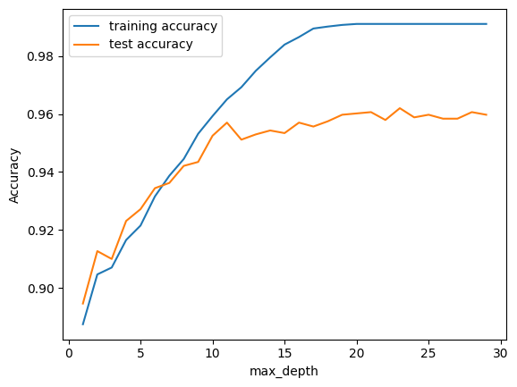

**Fig 6.3: Training & Testing accuracy for Decision Tree**

#storing the results. The below mentioned order of parameter passing is important.

storeResults('Decision Tree',acc_test_tree,f1_score_test_tree,

recall_score_train_tree,precision_score_train_tree)

**GAUSSIAN NAÏVE BAYES**

# Gaussian Naive Bayes Classifier model

from sklearn.naive_bayes import GaussianNB

# instantiate the model

nb = GaussianNB()

# fit the model

nb.fit(X_train, y_train)

# predicting the target value from the model for the samples

y_train_nb = nb.predict(X_train)

y_test_nb = nb.predict(X_test)

# computing the accuracy, f1_score, Recall, precision of the model performance

acc_train_nb = metrics.accuracy_score(y_train, y_train_nb)

acc_test_nb = metrics.accuracy_score(y_test, y_test_nb)

print("Gaussian Naive Bayes: Accuracy on training Data: {:.3f}".format(acc_train_nb))

print("Gaussian Naive Bayes: Accuracy on test Data: {:.3f}".format(acc_test_nb))

print()

f1_score_train_nb = metrics.f1_score(y_train, y_train_nb)

f1_score_test_nb = metrics.f1_score(y_test, y_test_nb)

print("Gaussian Naive Bayes: f1_score on training Data: {:.3f}".format(f1_score_train_nb))

print("Gaussian Naive Bayes: f1_score on test Data: {:.3f}".format(f1_score_test_nb))

print()

recall_score_train_nb = metrics.recall_score(y_train, y_train_nb)

recall_score_test_nb = metrics.recall_score(y_test, y_test_nb)

print("Gaussian Naive Bayes: Recall on training Data: {:.3f}".format(recall_score_train_nb))

print("Gaussian Naive Bayes: Recall on test Data: {:.3f}".format(recall_score_test_nb))

print()

precision_score_train_nb = metrics.precision_score(y_train, y_train_nb)

precision_score_test_nb = metrics.precision_score(y_test, y_test_nb)

print("Gaussian Naive Bayes: precision on training Data: {:.3f}".format(precision_score_train_nb))

print("Gaussian Naive Bayes: precision on test Data: {:.3f}".format(precision_score_test_nb))

# computing the classification report of the model

print(metrics.classification_report(y_test, y_test_nb))

training_accuracy_nb = []

test_accuracy_nb = []

# try different priors

priors = [None, [0.1, 0.9], [0.2, 0.8], [0.3, 0.7], [0.4, 0.6], [0.5, 0.5]]

for prior in priors:

nb_test = GaussianNB(priors=prior)

nb_test.fit(X_train, y_train)

# record training set accuracy

training_accuracy_nb.append(nb_test.score(X_train, y_train))

# record generalization accuracy

test_accuracy_nb.append(nb_test.score(X_test, y_test))

# plotting the training & testing accuracy for different priors

plt.plot(range(len(priors)), training_accuracy_nb, label="training accuracy")

plt.plot(range(len(priors)), test_accuracy_nb, label="test accuracy")

plt.xticks(range(len(priors)), [str(prior) for prior in priors])

plt.ylabel("Accuracy")

plt.xlabel("Priors")

plt.legend();

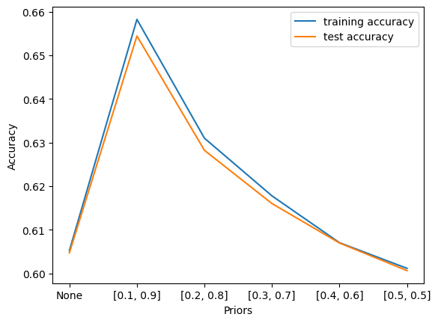

**Fig 6.4: Training & Testing accuracy for Gaussian Naïve Bayes**

# storing the results. The below mentioned order of parameter passing is important.

storeResults('Gaussian Naive Bayes', acc_test_nb, f1_score_test_nb,

recall_score_train_nb, precision_score_train_nb)

**MULTI-LINEAR PERCEPTION**

# Multi-layer Perceptron Classifier Model

from sklearn.neural_network import MLPClassifier

# instantiate the model

mlp = MLPClassifier()

#mlp = GridSearchCV(mlpc, parameter_space)

# fit the model

mlp.fit(X_train,y_train)

#computing the accuracy, f1_score, Recall, precision of the model performance

acc_train_mlp = metrics.accuracy_score(y_train,y_train_mlp)

acc_test_mlp = metrics.accuracy_score(y_test,y_test_mlp)

print("Multi-layer Perceptron : Accuracy on training Data: {:.3f}".format(acc_train_mlp))

print("Multi-layer Perceptron : Accuracy on test Data: {:.3f}".format(acc_test_mlp))

print()

f1_score_train_mlp = metrics.f1_score(y_train,y_train_mlp)

f1_score_test_mlp = metrics.f1_score(y_test,y_test_mlp)

print("Multi-layer Perceptron : f1_score on training Data: {:.3f}".format(f1_score_train_mlp))

print("Multi-layer Perceptron : f1_score on test Data: {:.3f}".format(f1_score_train_mlp))

print()

recall_score_train_mlp = metrics.recall_score(y_train,y_train_mlp)

recall_score_test_mlp = metrics.recall_score(y_test,y_test_mlp)

print("Multi-layer Perceptron : Recall on training Data: {:.3f}".format(recall_score_train_mlp))

print("Multi-layer Perceptron : Recall on test Data: {:.3f}".format(recall_score_test_mlp))

print()

precision_score_train_mlp = metrics.precision_score(y_train,y_train_mlp)

precision_score_test_mlp = metrics.precision_score(y_test,y_test_mlp)

print("Multi-layer Perceptron : precision on training Data: {:.3f}".format(precision_score_train_mlp))

print("Multi-layer Perceptron : precision on test Data: {:.3f}".format(precision_score_test_mlp))

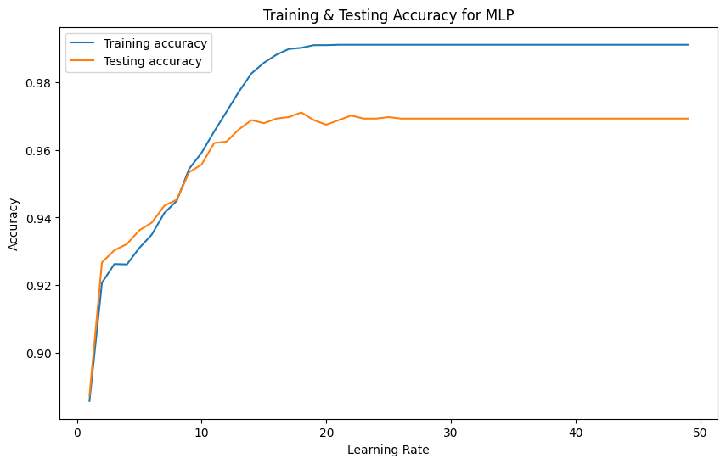

**Fig 6.5: Training & Testing Accuracy for MLP**

#storing the results. The below mentioned order of parameter passing is important.

storeResults('Multi-layer Perceptron',acc_test_mlp,f1_score_test_mlp,

recall_score_train_mlp,precision_score_train_mlp)

**#creating dataframe**

result = pd.DataFrame({ 'ML Model' : ML_Model,

'Accuracy' : accuracy,

'f1_score' : f1_score,

'Recall' : recall,

'Precision': precision,

})

#Sorting the datafram on accuracy

sorted_result=result.sort_values(by=['Accuracy', 'f1_score'],ascending=False).reset_index(drop=True)

ML_Model = ['Random Forest', 'LogisticRegression','DecisionTreeClassifier ','Gaussian Naive Bayes', 'Multi-layer Perceptron']

accuracy = [acc_test_forest, acc_test_log, acc_test_tree, acc_test_nb, acc_test_mlp]

# Creating a DataFrame

results = pd.DataFrame({

'ML Model': ML_Model,

'Accuracy': accuracy

})

**# Sorting the DataFrame based on Accuracy**

sorted_results=results.sort_values(by=['Accuracy'],ascending=False).reset_index(drop=True)

**# Plotting the bar chart**

plt.figure(figsize=(10, 6))

bars = plt.bar(sorted_result['ML Model'], sorted_result['Accuracy'], color=['skyblue', 'lightgreen', 'lightcoral', 'lightsalmon'])

plt.title('Testing Accuracy Comparison of ML Models')

plt.xlabel('ML Model')

plt.ylabel('Testing Accuracy')

plt.ylim(0, 1) # Set the y-axis limit between 0 and 1 for accuracy values

plt.xticks(rotation=45, ha='right') # Rotate x-axis labels for better readability

**# Displaying precise values on top of each bar**

for bar, value in zip(bars, sorted_result['Accuracy']):

plt.text(bar.get_x() + bar.get_width() / 2 - 0.1, bar.get_height() + 0.01, f'{value:.3f}', ha='center', color='black')

plt.show()

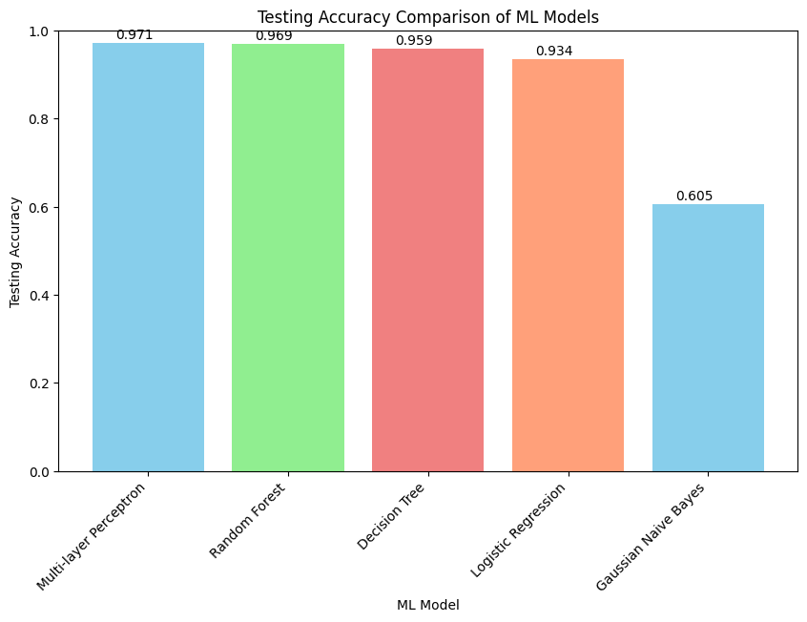

**Fig 6.6: Testing Accuracy Comparison of ML Models**

# dispalying total result

sorted_result

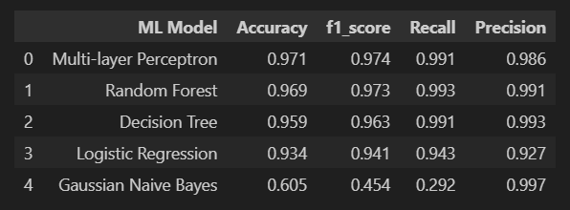

**Fig 6.7: Various ML Models Results**